
Kestrel Class Homework – Spring Term 1
Ancient Egyptians
To be submitted by 24.02.25

Writing  Can you create a book about the Ancient Egyptians? The book could include information about their every day life, food and drink, clothing, religion, hierarchy and you could even compare them to a period we have already studied in History. If you would prefer a fiction text, you could write an adventure story during the Ancient Egyptian period. | Research  Who was Tutankhamun? Find out about them and create a fact file or PowerPoint about them!
Artwork  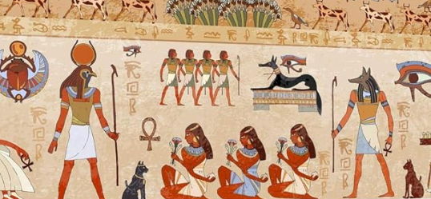  Create a piece of art following the same styles as the traditional Egyptian art. | Maths  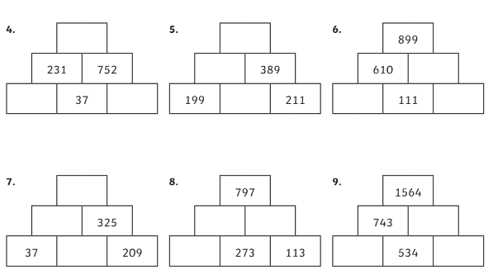  Complete the pyramids. Two boxes must add together to equal the number in the box above them both.
Something else  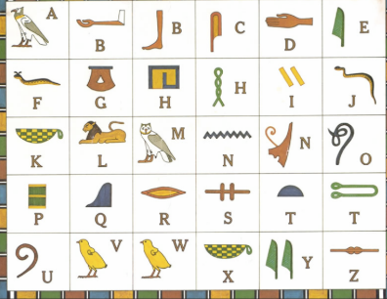  Can you create a message using these hieroglyphics? | Modelling  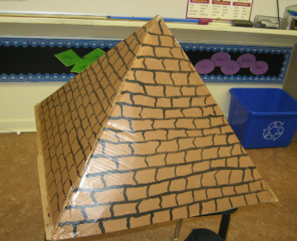  Create a pyramid using materials of your choice. Evaluate your model to see if it can withstand water.

